Multicast

📶 What Is Multicast in Networking?
# Source: Chatgpt (GPT‑5 Mini) at [12/9/2025]
Multicast is a one-to-many communication method where a device sends data to a specific group of interested devices, rather than to all devices (broadcast) or just one (unicast).

📦 Belongs to:
# Source: Chatgpt (GPT‑5 Mini) at [12/9/2025]
✅ Types of Network Transmission Modes
Alongside Unicast (one-to-one) and Broadcast (one-to-all)

🧠 Definition:
# Source: Chatgpt (GPT‑5 Mini) at [12/9/2025]
In multicast, data is transmitted once by the sender and delivered to multiple selected recipients who have subscribed to a multicast group.

🧾 Examples of Multicast Use
# Source: Chatgpt (GPT‑5 Mini) at [12/9/2025]
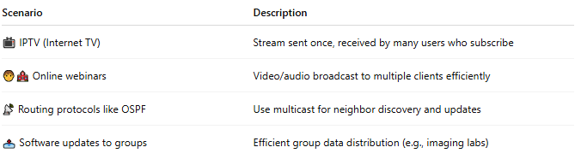
Scenario | Description
📺 IPTV (Internet TV) | Stream sent once, received by many users who subscribe
🧑‍🏫 Online webinars | Video/audio broadcast to multiple clients efficiently
📡 Routing protocols like OSPF | Use multicast for neighbor discovery and updates
📤 Software updates to groups | Efficient group data distribution (e.g., imaging labs)

🧮 Multicast IP Address Ranges
# Source: Chatgpt (GPT‑5 Mini) at [12/9/2025]
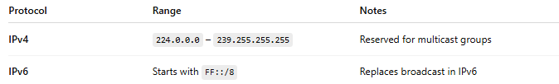
Protocol | Range | Notes
IPv4 | 224.0.0.0 – 239.255.255.255 | Reserved for multicast groups
IPv6 | Starts with FF::/8 | Replaces broadcast in IPv6
Devices join multicast groups using protocols like IGMP (IPv4) or MLD (IPv6).

📌 How It Works
# Source: Chatgpt (GPT‑5 Mini) at [12/9/2025]
- Sender sends one copy of data to a multicast group address.
- Only devices that subscribed (joined the group) receive the data.
- Network switches/routers handle delivery efficiently, minimizing unnecessary traffic.

✅ Advantages
# Source: Chatgpt (GPT‑5 Mini) at [12/9/2025]
- ⚡ Efficient bandwidth use — sends one stream to many
- 📶 Scales well for many receivers
- 🎯 Targets only subscribers, not the whole network

❌ Disadvantages
# Source: Chatgpt (GPT‑5 Mini) at [12/9/2025]
- ⚙️ Requires multicast-aware routers/switches
- 🧪 More complex to configure than unicast
- ❌ Not widely supported on the public internet (used mostly in internal networks)

📋 Comparison Table
# Source: Chatgpt (GPT‑5 Mini) at [12/9/2025]
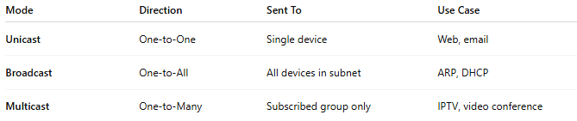
Mode | Direction | Sent To | Use Case
Unicast | One-to-One | Single device | Web, email
Broadcast | One-to-All | All devices in subnet | ARP, DHCP
Multicast | One-to-Many | Subscribed group only | IPTV, video conference

🔧 Protocols Using Multicast
# Source: Chatgpt (GPT‑5 Mini) at [12/9/2025]
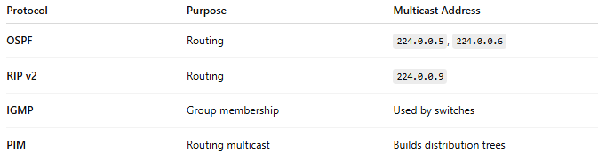
Protocol | Purpose | Multicast Address
OSPF | Routing | 224.0.0.5, 224.0.0.6
RIP v2 | Routing | 224.0.0.9
IGMP | Group membership | Used by switches
PIM | Routing multicast | Builds distribution trees

